# Hangman (CLL) Program

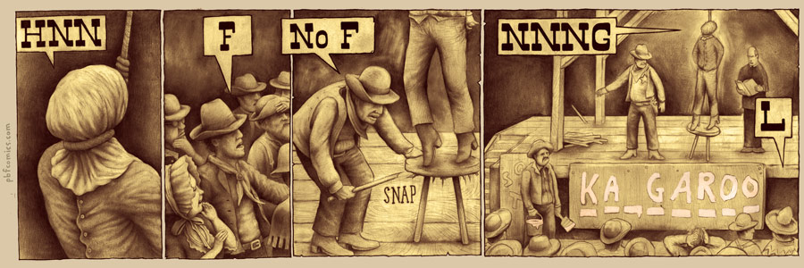

This program will implement a circularly linked list of strings to be used to play hangman. It will read its wordbank from a file created by you, and then have the user guess letters.

# The Input File

This file will consist of a list of words in this format:

WORD1

WORD2

WORD3

;

The ; ends the input file.

# Required Function: Populate

This function takes the head pointer, and it reads in words from the file. It puts those words into a circularly linked list that will be used to choose words to play the game. It returns 0 for success, and -1 for failure.

# Required Function: ChooseWord

This function takes the head pointer as its argument. It randomly generated an integer 0 to 1000. It then advances the pointer that many times to find the word it will use. It returns the word, or an empty string if there was an error.

# Required Function: Destroy

This function takes the head pointer as an argument. It deletes all elements of the list; this needs to be called before exiting the program. (returns no value)

# Required Function: PlayRound

This function calls ChooseWord, and plays a round of hangman. It returns -1 for an error, or it returns a 1 if the player won, or a 0 if the player lost.

# Required Function: Report

This function displays the number of wins, losses, and the win percentage. It is to be run after the user chooses to quit.

# Notes

The program should display a drawing of the hangman board.

The program must display the letters that the user previously guessed.

The program needs to display an error message when a function returns an error code.

The program must check for the successful opening of all files it uses.

The program must be well-commented.

The program must be printed out and turned in with this paper attached. (OTHER SIDE UP)

|  |  |  |
| --- | --- | --- |
| Criteria | Points Possible | Points Earned |
| Error checks file opening correctly | 5 |  |
| Loops when completed to ask if user wants to go again | 5 |  |
| ChooseWord works | 15 |  |
| Populate works | 15 |  |
| Playround works | 30 |  |
| Report works | 15 |  |
| Destroy works | 5 |  |
| Handles errors from these functions | 5 |  |
| Commented | 5 |  |
| Late | -5 points per day late |  |
| Total: | 100 |  |